

A Project

Report On

**AnkiStyle Clothes App**

By

**Ankita Anant Sutar**

**B.E Computer Engineering**

**Batch: - 2020-5735**

**Center: -Thane**

Under the Guidance of,

**Shalini Kumari.**

**Technical Trainer**

**EduBridge**

(School of Coding)

**Introduction:**

This Project **AnkiStyle Clothes App** has been developed in **Java and Object Oriented Concepts**. This is a Desktop application .The purpose of this Application is to automate the existing manual system by the help of computerized billing and Order collections in computer software.

In this project, users can generate bill in very less time. In this Application, users can register for first time to the application ,user can see there profile ,If user is existing user then they can login in to the application etc. This project can be advanced by adding more products into application.

Software Requirements:

Front end: Java/J2SE technologies

IDE: Eclipse IDE for Java Developers

Operating System: Window 10

Output:

**1.Welcome Page:**

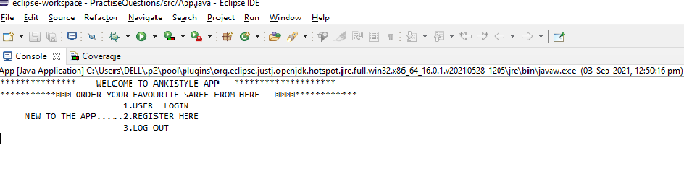

Fig: 1

**2.Register page:**

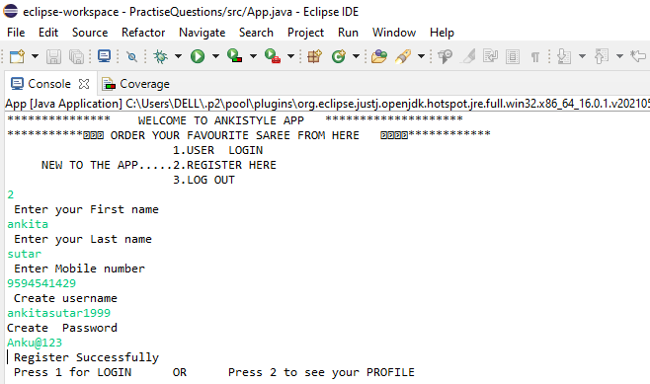

Fig : 2

**3.Display profile**:

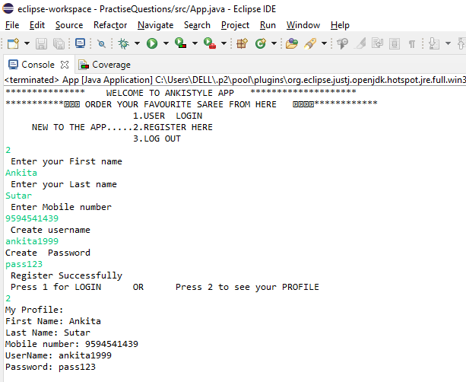

Fig: 3

**4. Login :**

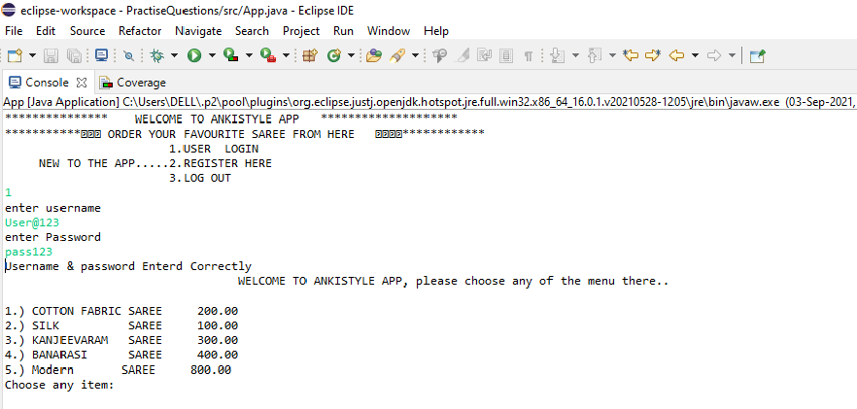

Fig: 4

**5.Menu Selection :**

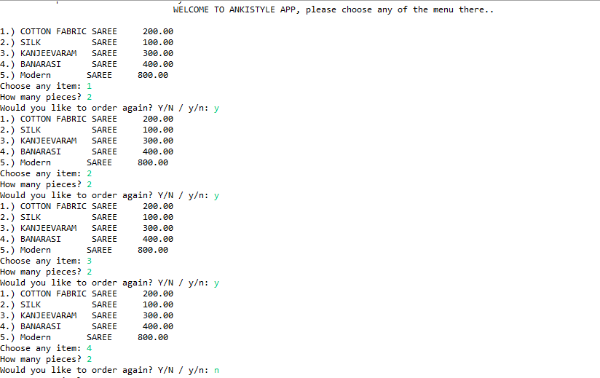

Fig: 5

**6. Billing & Payment :**

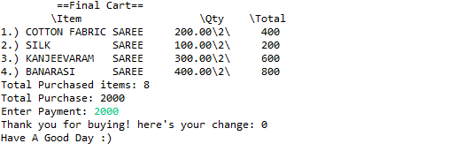

Fig: 6

***AnkiStyle Clothes Application***

***Has been completed***